D7 Expert Review Report
Regime-conditioned Ordinal Spatial Structure and Representativeness | v2.3
Status: Scientific score released; claim-specific action gates retained
Run: D7-LOCAL-20260726T074210Z
Coverage: 2025-08-01 00:00:00 to 2026-04-13 23:00:00

1. Executive verdict
D7 v2.3 is complete as a regime-conditioned ordinal spatial-structure assessment with family-to-node support validation and separate scientific report and decision-gate interfaces.
Ordinal topology is author-confirmed and inventory-reconciled. Shared family support yields 8 L3 candidates, while node validation retains 3 final L3 templates. D7_report_score contains 39,648 rows. Swap Top-1 is 0.70 (95% CI 0.57-0.80, n=60), so node-specific hard Veto remains disabled.

2. Scope and dimensional independence
- D7 evaluates spatial role identity and structural representativeness, not hardware fault type.
- D1 covers sensor-intrinsic health; D2 covers continuity/availability; D4 covers physical value/rate constraints; D6 covers temporal synchronization between parallel counterparts.
- Local D7 consumes no D1-D6 score, state or event. D1/D2/D4 appear only in the isolated Sensitivity Track.
- QR/QIR provide exogenous context only. Low D7_raw is unlabeled structural evidence, not a confirmed fault.

3. Current data and outputs
Sensitivity provenance is bound to frozen D1 release D1REL-1.3.0-f6074be3751f and exact D2/D4/Local artifact hashes. The Sensitivity Track remains pending_not_produced and cannot write authoritative report or gate outputs.
Measure | Current result | Interpretation
Hourly windows | 86,016 | 2025-08-01 00:00:00 to 2026-04-13 23:00:00
D7 raw | mean 3.097; median 3.114 | Comparative research evidence
Low-score fraction | 46.0% | Not a fault prevalence estimate
Candidate events | 529 | Unreviewed and unlabeled
OOD hold | 15.5% | Explicit posterior rejection
D7 total / D6 evaluable | 39648 / 19824 | Scientific aggregation ready

4. Support and applicability
Tier | Templates | Policy
L2 | 39 | Scientific score
L1 | 14 | Diagnostic only
L3 | 3 | Action candidate

ORP retains diagonal robust Z with alpha=1.00, while evidence maturity is graded independently. L2 requires effective blocks and month coverage and remains scientific-score grade (maximum holdout FAR 0.500); L3 additionally requires block-bootstrap stability and blocked holdout FAR <=0.10 (observed maximum 0.066).

5. Validation and sensitivity
Criterion | Estimate | Target | Result
swap_AUROC | 0.912 | >= 0.90 | PASS
swap_AUPRC | 0.870 | >= 0.80 | PASS
swap_Top1 | 0.700 | >= 0.80 | FAIL
common_mode_FAR | 0.046 | <= 0.10 | PASS
zone_coherent_FAR | 0.057 | <= 0.10 | PASS
switch_chatter_rate | 0.000 | <= 0.05 | PASS
scientific_score_release | 1.000 | nan 1.00 | PASS
sensor_veto_release | 0.000 | nan 1.00 | FAIL
deployment_release | nan | manual nan | FAIL

Same-line position swaps are scored with frozen templates. Freeze, temporal ramps, common/zone-coherent changes, DO4 floor behavior and dropout are orthogonality controls. Detection and FAR pass, but node localization remains below release quality.
Track metric | Estimate | Target | Result
IE_track | 0.048 | <=0.20 | PASS
event_jaccard | 0.825 | >=0.80 | PASS
culprit_spearman | 0.962 | >=0.80 | PASS

6. Topology and D6 interface
The declared registry contains 14 nodes, 10 longitudinal edges and seven peer pairs. 5 finite candidate mappings exceed the review threshold. They cannot mutate declared topology.
- Ordinal research topology is confirmed; maintenance provenance, production documentary audit and two-person approval remain pending.
- D7-to-D6 zone consensus contains 19,824 evaluable rows.
- Process-coherence Guard is active for 0 pair-hours; sensor-specific hard Veto is active for 0.
- D6_raw is the sole D6 numeric source; D1 and D7 contribute interpretation and action governance only.

7. SCI figure review
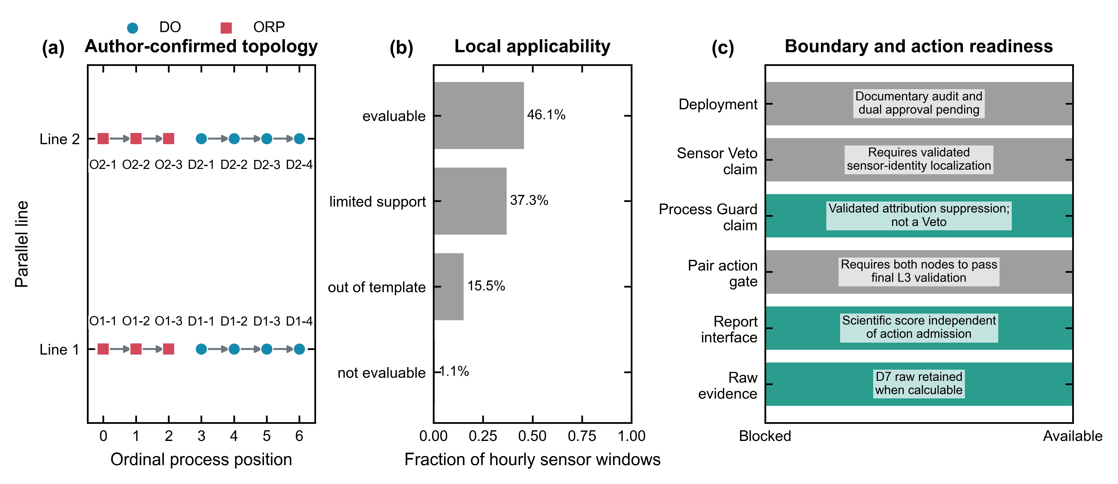
Figure D7-1 | Author-confirmed topology, applicability and release boundary.
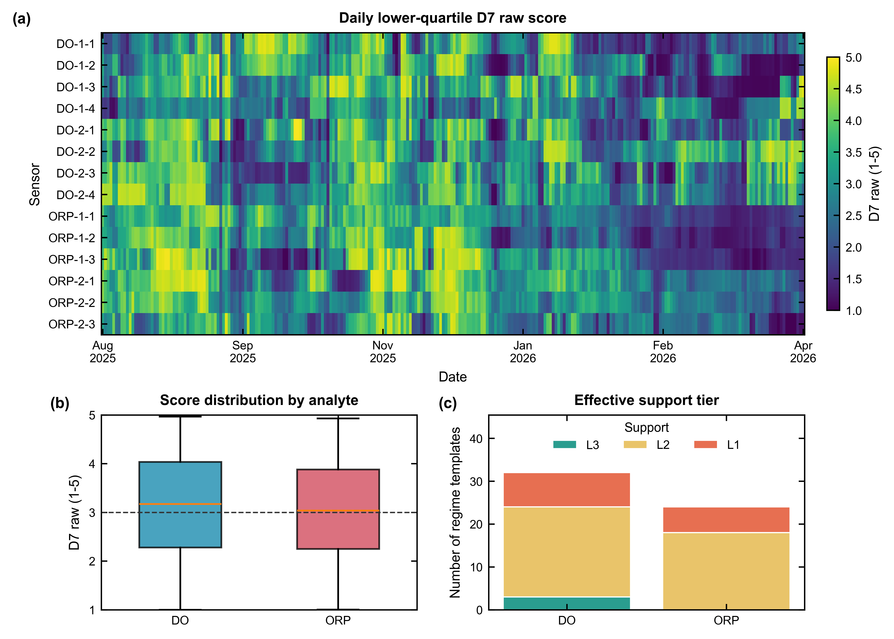
Figure D7-2 | Spatiotemporal D7 structure and effective support.
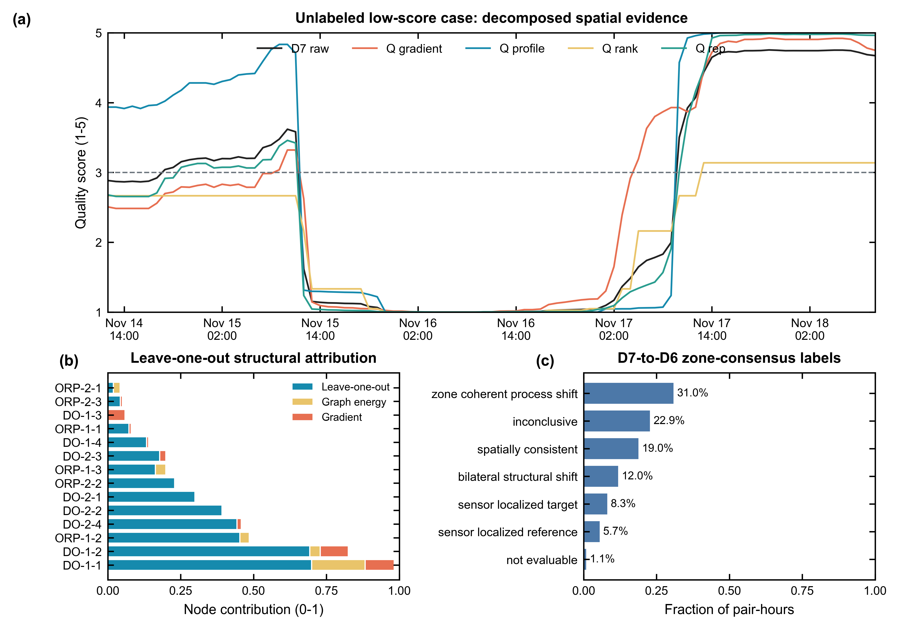
Figure D7-3 | Evidence decomposition, node influence and zone consensus.
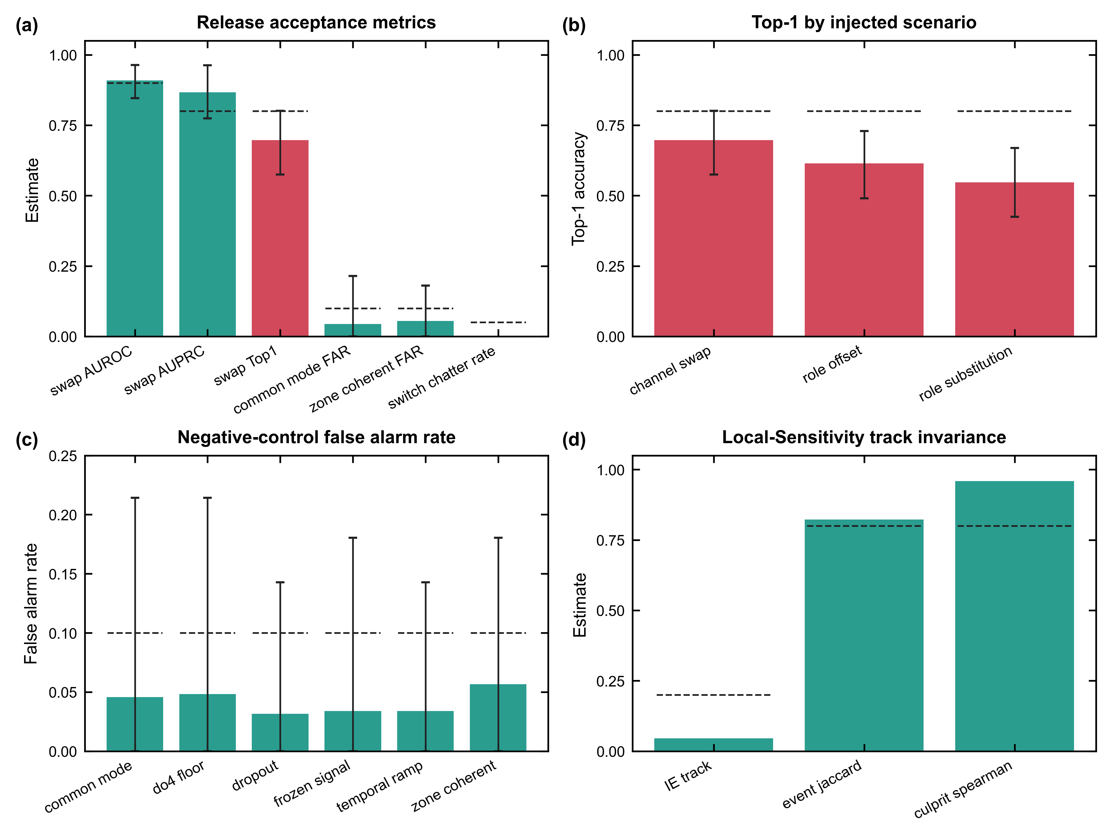
Figure D7-4 | Validation and Local-Sensitivity invariance.
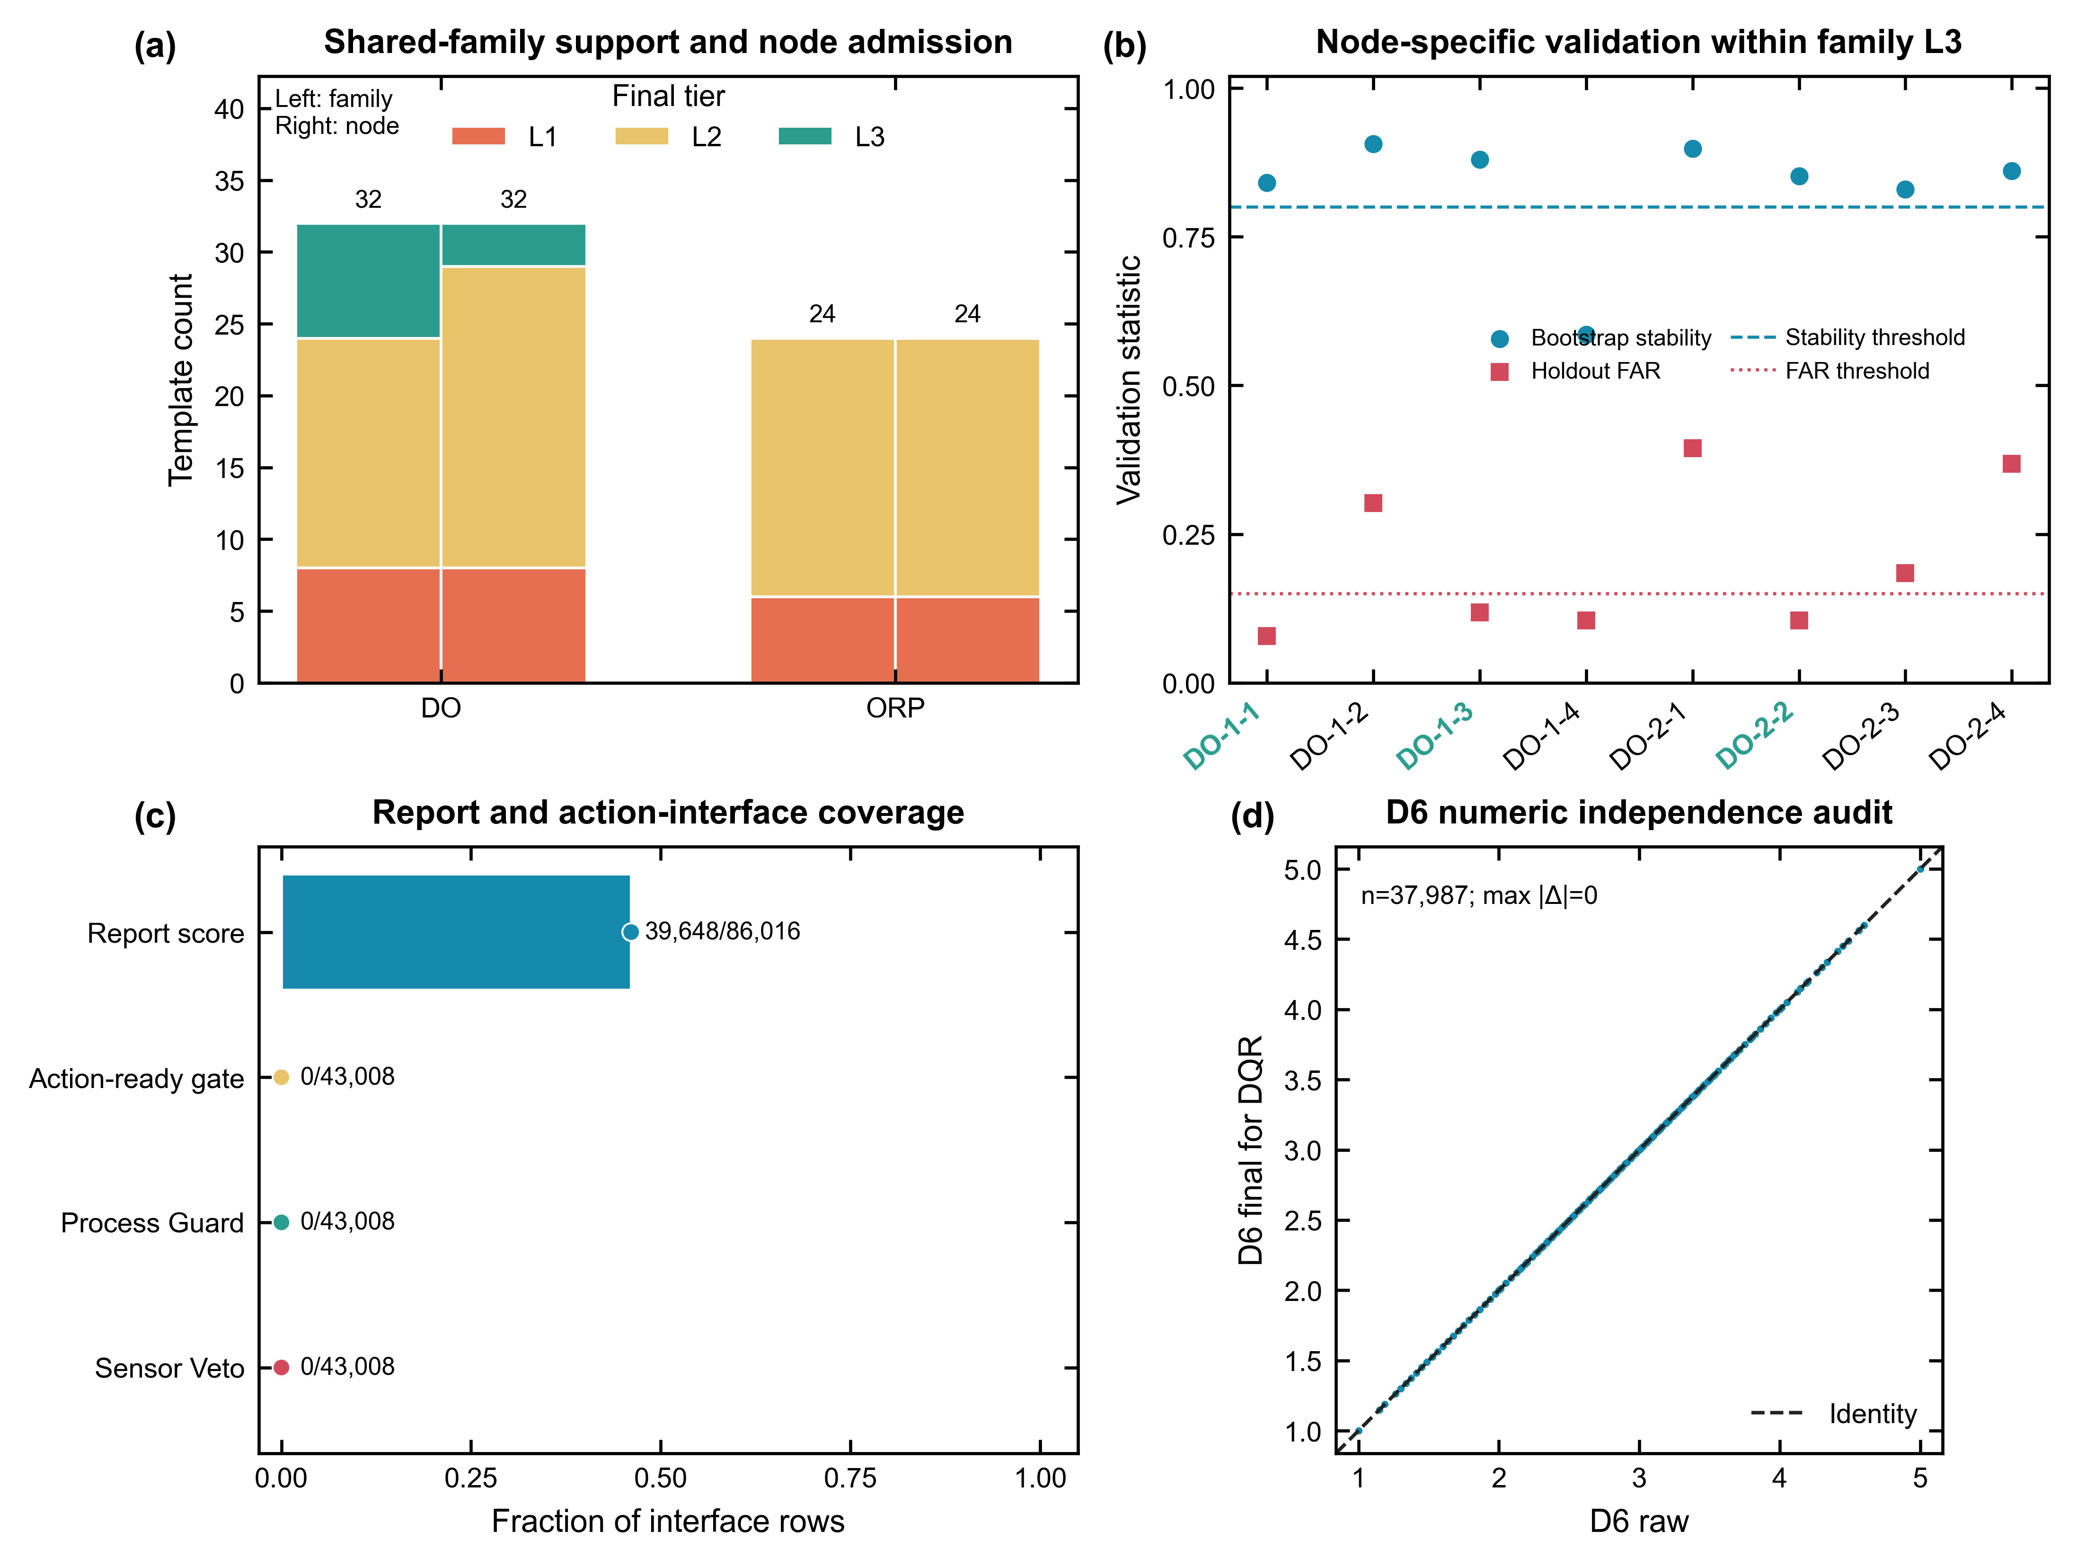
Figure D7-5 | Support, regime, topology and release governance.

8. Critical limitations
- Research topology is confirmed, but production documentary evidence and maintenance provenance are not dual-approved.
- Effective support is L1=14, L2=39, L3=3; L1 remains diagnostic only.
- Swap Top-1 is 0.70 (95% CI 0.57-0.80) versus the 0.80 target.
- The 529 candidate events lack external truth and cannot be called confirmed faults.
- Regime transition FAR and topology candidate recall require external truth.

9. Release decision
The branch is suitable for final WW-DQS subscore aggregation with claim-specific action gates. Automated plant-control deployment remains outside the present evidence scope.
- Use score-eligible D7 rows with confidence-aware missing-dimension renormalization.
- Use process-coherence Guard only for persistent final-L3 evidence and never report it as Veto.
- Raise blocked-holdout Top-1 to at least 0.80 without weakening negative-control FAR.
- Complete D6-D7 overlap and ablation analysis before freezing WW-DQS weights.
- Obtain documentary approval before automated deployment.

